Kingdom of Saudi Arabia  Ministry of Education  Eastern Province Education Department  Tarbeat Al-Ajial International Schools |  |  |  |  |  |  | Date: ……/………/..………  Subject: Computer  Grade: G1
……………… |  | Seat Number |  | ……………………………………….. |  |  |  | Student’s Name
2nd Semester Exam (2nd Session) 2026/2025
Sign. | Consultative Name |  | Sign. |  | Corrector’s Name | Marks in letters |  |  | Marks  in numbers
 |  |  |  |  |  |  |  |  | 40

Question A: Match the following

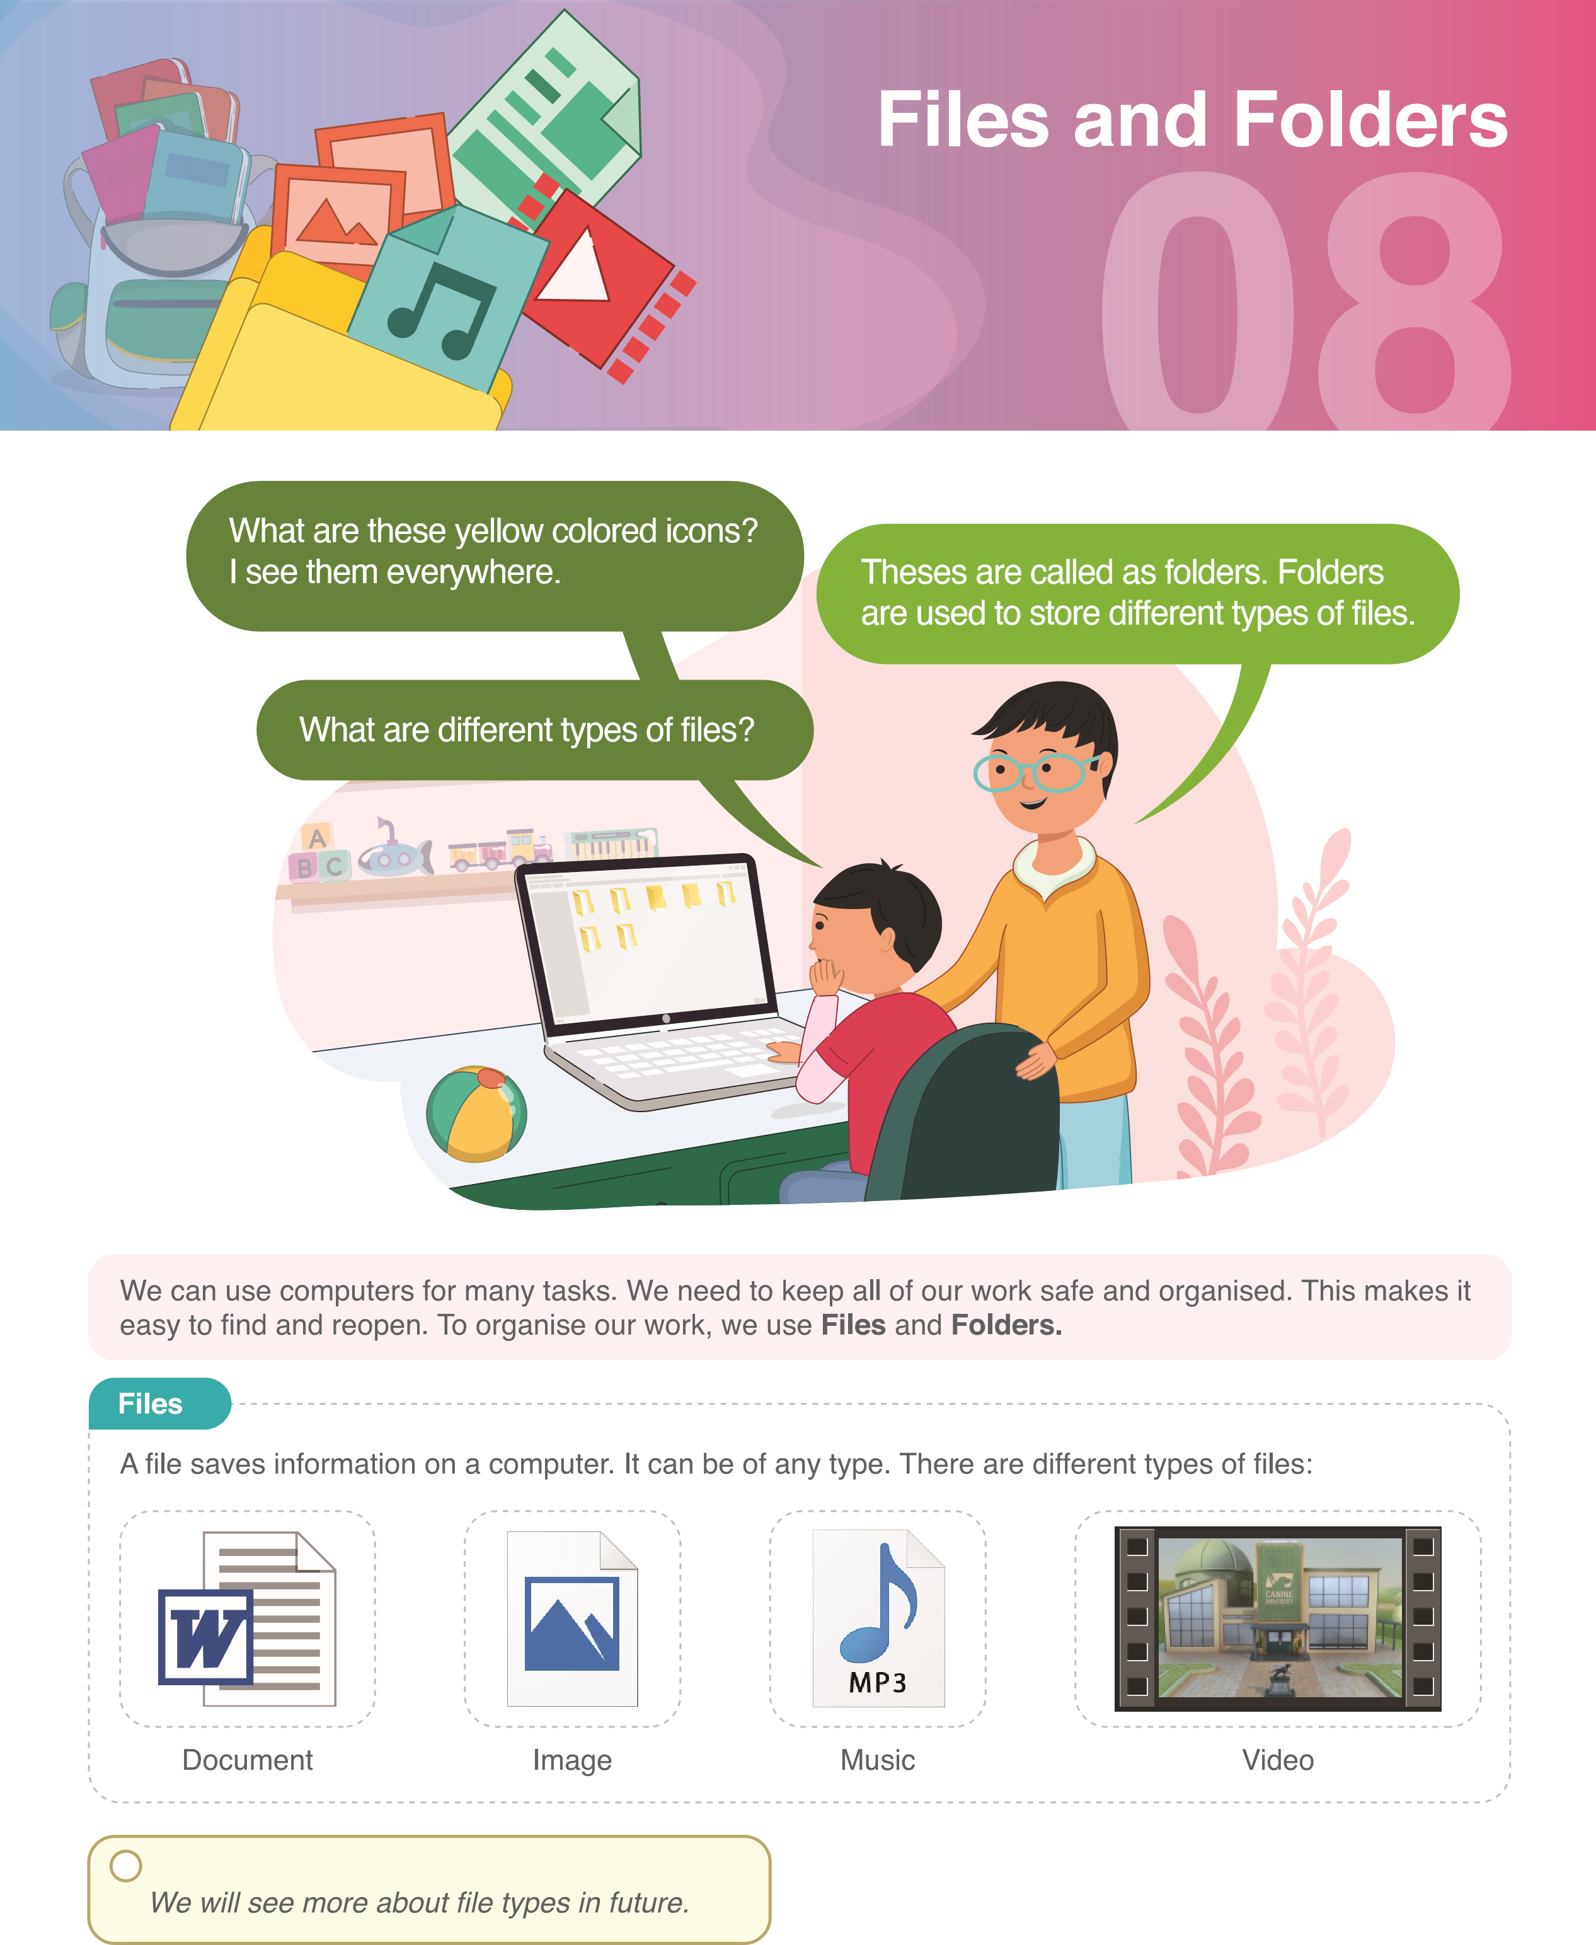 | Image
 | Document
 | Music
 | Video
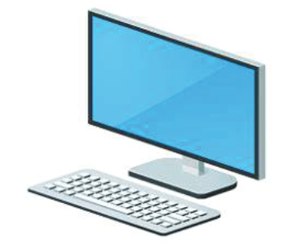 | PC

Question B: state whether (True) or (False)

- Charts, drawings, and photographs are examples of image files.
a. True b. False

- Animation is when different images look like they are moving.
a. True b. False

- The medium through which computers share information is called the Internet.
a. True b. False

- The software used to connect to the internet is called Browser.
a. True b. False

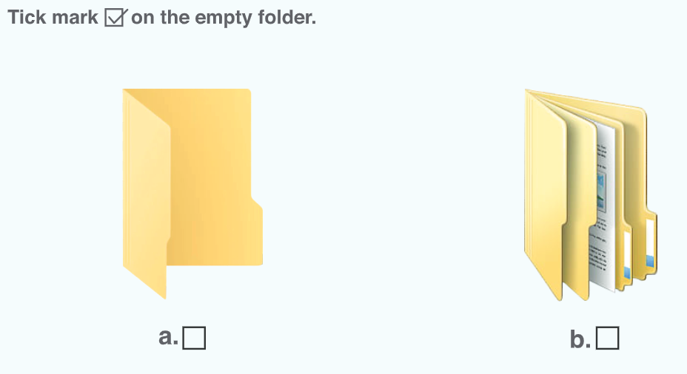
Question C: Tick mark ((✔️ on the empty folder
Good Luck

